Spark SQL
Spark SQL is a module of Apache Spark that allows you to work with structured & semi structured data using SQL queries as well as DataFrame APIs.
It is especially useful in data engineering & analytics as it allows SQL developers, analysts, & data engineers to query large datasets without needing to work entirely with programming APIs.
A typical Spark SQL workflow
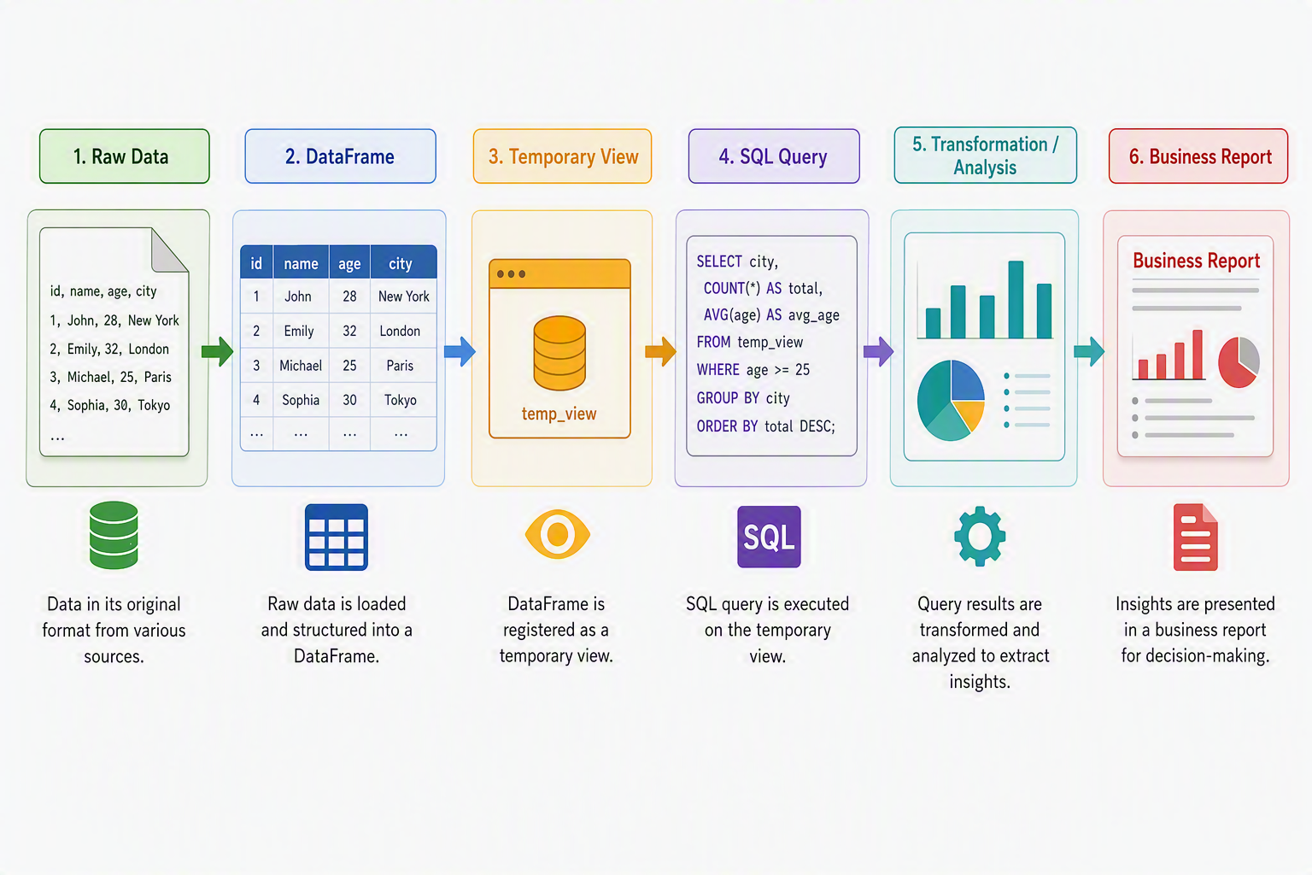

Temporary Views
A Temporary View is a logical SQL representation of a Spark DataFrame which allows a DataFrame object to be queried using standard SQL syntax.
Why Temporary Views are useful?
Temporary Views provide a bridge between:
- DataFrame processing
- SQL Analytics
- Business reporting
- Data exploration
Characteristics of Temporary View
A temporary view:
- Exists only during the Spark Sessions.
- Does not store the data permanently.
- Provides a SQL-accessible representation of a DataFrame.
- Can be queries using Spark-SQL.
- It is useful for ad-hoc analysis & reporting.
Global Temporary View
Global temporary view is available across Spark sessions within the application through Sparks’ global temporary database.
SQL Queries
Once a DataFrame has been exposed as a temporary view, Spark SQL can be used to analyze it.
SQL Functions
- Aggregate functions
- Window functions
- Date functions
- String functions
- Mathematical functions
- Conditional functions
- Conversion function

Demo
Business Reporting Use Case
Create:
- Department-wise reports
- Salary analytics
- Trend reports

